**Source Code:**

using System;

using System.Collections.Generic;

using System.ComponentModel;

using System.Data;

using System.Drawing;

using System.Linq;

using System.Text;

using System.Windows.Forms;

using Oracle.DataAccess.Client; // ODP.NET Oracle managed provider

using Oracle.DataAccess.Types;

using System.Data.SqlClient; // ODP.NET SQL server managed provider

namespace Final_Project

{

public partial class Form1 : Form

{

public Form1()

{

InitializeComponent();

}

private void button1_Click(object sender, EventArgs e)

{

string oradb = "Data Source=rice-opd2-2w7;User Id=hr;Password=hr;";

OracleConnection conn = new OracleConnection(oradb); // C#

conn.Open();

OracleCommand cmd = new OracleCommand();

cmd.Connection = conn;

cmd.CommandText = "select order_id, first_name, last_name"

+ " from tbl_orders o, tbl_customers c"

+ " where o.customer_id = c.customer_id";

cmd.CommandType = CommandType.Text;

OracleDataReader dr = cmd.ExecuteReader();

while (dr.Read())

{

listBox1.Items.Add("Order ID: " + dr.GetValue(0)

+ "; Customer: " + dr.GetString(1) + " " + dr.GetString(2));

}

conn.Dispose();

}

private void button2_Click(object sender, EventArgs e)

{

string connetionString = null;

SqlConnection connection;

SqlCommand command;

string sql = null;

SqlDataReader dataReader;

connetionString = "Server=216.47.157.180; Data Source=TCWXVUETIK55GIL; Initial Catalog=trouble_ticket; Integrated Security=True";

sql = "Select * from employees";

connection = new SqlConnection(connetionString);

try

{

connection.Open();

command = new SqlCommand(sql, connection);

dataReader = command.ExecuteReader();

while (dataReader.Read())

{

listBox1.Items.Add("Employee ID: " + dataReader.GetValue(0)

+ "; First name: " + dataReader.GetString(1));

}

dataReader.Close();

command.Dispose();

connection.Close();

}

catch (Exception ex)

{

MessageBox.Show("Can not open connection ! ");

}

}

}

}

**Sample Output:**

After I click the button of connect to Oracle:

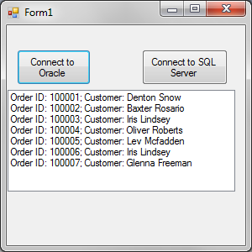

After I click the button of connect to SQL Server:

**Note:**

In our final project, the server which we use is the local one and it requests us to find the local server’s data source. For example, Data Source=rice-opd2-2w7 or Server=216.47.157.180.

**How to find the data source in Visual Studio:**

1. View menu 🡪 Server Explorer 🡪 Data Connection 🡪 Add Connection.

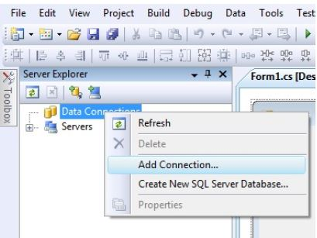

1. Select data source

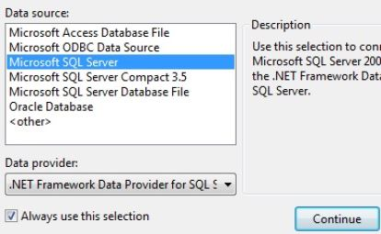

1. If you choose MS SQL Server, you will select server name and database name.

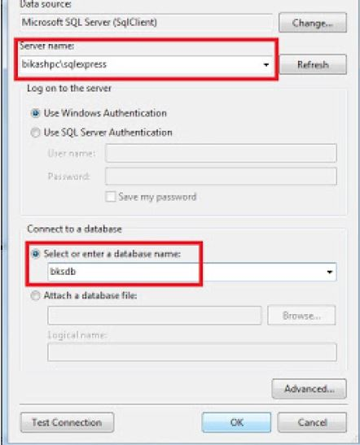

1. Now, you connect the database. Then you can find the data source.

(data connections 🡪 properties 🡪 connection string)

